Interim Guidance for COVID-19 Prevention in Virginia PreK-12 Schools

EXECUTIVE SUMMARY

There is no greater priority than the health and welfare of Virginia’s children, and parents have the fundamental right to make decisions concerning the care of their children.

These three core principles found in Executive Order 2 reaffirm:
- Parents are in charge of their children’s health, wellbeing and education,
- Schools must be open five days a week for in-person learning, and
- The Commonwealth and school divisions must provide a safe and healthy school environment.

With freedom comes responsibility. This guidance clarifies the roles of parents, educators and the schools. The Virginia Department of Health and the Virginia Department of Education will continue to provide quality, actionable and up-to-date information on the pandemic so that parents can continue to make educated health decisions that are best for their child and family.

The virus that causes COVID-19 continues to evolve and the tools to fight the virus have expanded. As new variants emerge, the epidemiology may change; therefore, prevention strategies may need to be adjusted. This public health guidance has been updated to align with the current risk. A key lesson learned from early in the pandemic is that many students and families suffer when schools are not open to in-person learning. Keeping students in school, while also providing a safe environment to students, teachers and staff in K-12 schools, is the goal.

Mitigation strategies that reduce COVID-19 transmission can be reduced now that effective vaccines are available, and the current predominant variant (Omicron) is causing less severe disease. Foundational prevention strategies in schools, such as testing and improving ventilation, combined with common-sense actions of personal responsibility, such as staying home when sick, getting vaccinated, and hand-washing, can help reduce transmission in schools. Following public health recommendations to isolate at home after testing positive is also an important layer of safety for our school communities. For those who have tested positive or have been recommended to quarantine, wearing masks for the recommended time period and testing at appropriate intervals can help keep kids in school and keep everyone safe.

While children can be infected with COVID-19, experience illness, and spread the virus to others, cases in healthy children are usually mild with a low risk of developing severe illness. Children and adults with certain underlying medical conditions are at increased risk for severe illness. However, effective COVID-19 vaccines and treatments are available and have been shown to greatly reduce the risk of hospitalization and death. People ages 5 and up are eligible for COVID-19 vaccination, which reduces risks for the individual and, as coverage rates improve, for the entire community.

Students, staff, and teachers infected with COVID-19 may go on to transmit the virus to other high-risk individuals in their households and the community. This is an important consideration especially when the healthcare system and resources to care for these individuals is under strain. In this way, containing the spread of the virus in the school setting can help protect our healthcare system and its ability to care for the most high-risk and sick members of our community. There are many ways to reduce the spread outside of masking and social distancing.

This guidance provides further details for local health and school officials and parents to inform their decision making around COVID-19. The benefit of mitigation efforts must always be weighed against the cost to children’s overall wellbeing. Mitigation efforts should be made in consultation with VDH and local health authorities.

Strategies to Prevent Transmission of COVID-19 in Schools

When the following prevention model has been implemented, studies have shown that infections and outbreaks in schools were reduced. Factors to guide decision-making about prevention strategies and school operations include:
- Consult public health to understand local transmission and disease trends
- Understand community level vaccination coverage
- Consider the level of impact to a school by identifying, monitoring and reporting outbreaks to public health
- Understand community and school capacity and needs
- Determine and implement a layered approach with multiple prevention strategies, in consultation with VDH and the local health department

Consult with VDH and other public health authorities to understand local transmission and disease trends

Working with VDH and the local health department can help school officials understand how the virus is spreading, who is being affected, and whether the current circulating variant is causing severe illness. Data on COVID-19 cases, testing, hospitalizations and deaths are helpful in understanding disease trends and can be found on VDH data dashboards.

Understand Community Level Vaccination Coverage

To understand community or locality level vaccination coverage, review locality level vaccination coverage data on the VDH Vaccine Data Dashboards. Age-group vaccination coverage at the locality level can be viewed on the “Demographics” tab.

For school-level data, VDH has developed a COVID Coverage Rate Report that provides those with access to Virginia Immunization Information System (VIIS) with a school-level vaccination coverage rate based on an uploaded school roster. Schools may contact the VIIS Help Desk at 804-864-7028 for assistance with a coverage rate report.

Consider the Level of Impact to a School
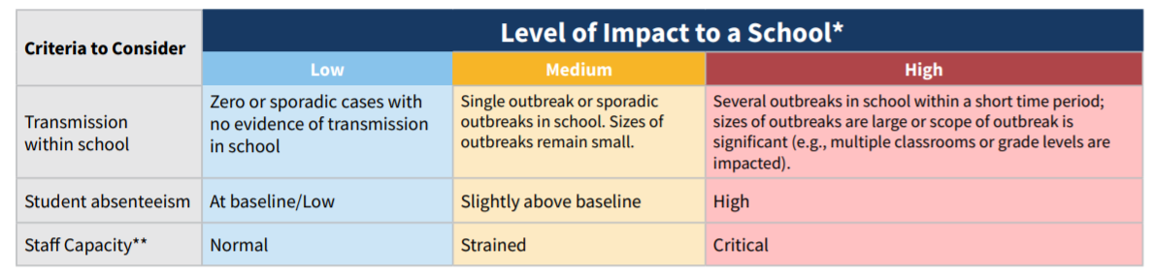
*Schools should collaborate with local health departments on outbreak investigations and contact tracing. Depending on the level of COVID-19 transmission in the school and outbreak status, public health may recommend adjustment to prevention strategies. If a school is conducting a COVID-19 testing program, screening testing data can also be helpful.
**This subjective assessment should factor in a school’s ability to maintain adequate staff for facility operations, transportation, teaching, and administrative functions. It should include input from teachers/staff regarding their availability to provide in-person instruction.

The level of impact that COVID-19 transmission is having within a school itself should be evaluated per the framework above and should consider whether the currently circulating variant causes severe illness in children or adults. VDH and/or the local health department should be consulted for advice on how to interpret data on cases and outbreaks. If the level of impact to a school is worsening, or if medium or high levels of transmission within a school are ongoing and the circulating variant is causing more serious or severe illness, changes to current strategies may need to be considered. To inform these decisions, school officials should work with local health departments to assess and consider:
- the number of outbreaks experienced and their proximity in time to each other;
- the size of any outbreak(s) (number of cases and close contacts identified);
- the level of spread within the school (e.g., whether cases are confined to a particular classroom or grade level);
- the severity of illness caused by the circulating variant;
- the level of student and/or staff absenteeism due to illness or necessary isolation/quarantine and the staff capacity

Understand the Capacity and Needs of your Community and School

Students benefit from in-person learning; maintaining in-person instruction is a priority. This guidance aims to balance the goal of disease prevention and the goal of providing in-person educational instruction. The absence of in-person educational options may disadvantage all children but has particular impact on certain types of learners. The negative impacts of remote learning for some children should be an integral part of planning. State law requires in-person options be made available to all students in Virginia during the 2021-2022 school year.

The feasibility of certain prevention strategies, including any harmful impacts a strategy may have, should be assessed to help decide what combination of strategies is best. For example, if a school cannot maintain operations while maintaining distances of 3 feet between students in classrooms, it would be especially important to focus on and layer other prevention strategies such as, testing programs, adequate or increased ventilation, ensuring appropriate hand hygiene opportunities, staying home when sick, supporting parents who choose to send their child to school with a mask, and regular cleaning and disinfecting.

The needs of special populations within a school community such as English learners, students who need special education or mental health services, or students who may not have reliable internet access at home should be understood if a school needs to temporarily convert to virtual learning or if individual students need to temporarily convert to virtual learning during necessary quarantine periods. Offering staff, students, and families the opportunity to ask questions and share concerns can provide meaningful input to help shape decisions on the right combination of prevention strategies.

Determine and Implement a Layered Approach with Multiple Prevention Strategies
All schools/school divisions should work with VDH and their local public health departments to assist in determining the layered prevention strategies that are appropriate. The selection of strategies should be informed by the levels of community transmission, the severity of illness caused by currently circulating variant(s), local vaccine coverage, advantages and disadvantages of potential strategies, and the level of impact to a school, including the use of screening testing data to detect cases in schools if available.

Prevention Strategies
Implementing prevention strategies to reduce risk associated with COVID-19 is a shared responsibility between parents and families, school officials and staff, and local public health authorities.

Parents:
- Keeping children home when sick and seeking care and testing as appropriate
- Vaccination
- Masks

School Officials and Staff:
- Adequate and appropriate ventilation
- Physical distancing
- Encourage students, teachers and staff to stay home from work when sick, and to seek care and testing as appropriate. Make decisions about excluding children or staff from school or work due to illness.
- Educate staff regarding their choices pertaining to masking
- Offer COVID-19 Testing programs (Screening Testing, Diagnostic Testing, Test to Stay)
- Ensure handwashing and respiratory etiquette
- Clean and maintain healthy facilities
- Notify students and staff of known cases and/or exposures in combination with isolation and quarantine.
- Notify public health of outbreaks in a timely manner.

Public Health:
- Provide data and information to inform parent and family decisions
- Respond to reports of outbreaks at school
- Provide technical assistance on outbreak investigations, prevention strategies, and testing programs

Preventive Actions:

Prevention is most effective when appropriate strategies are layered together, and is especially important in areas experiencing substantial to high levels of community transmission and the severity of illness caused by the circulating variant(s) is increased or high. However, the need for layering specific strategies may vary. When considering adjustments in prevention strategies, data should be monitored closely (with adequate testing through the school or community) for any increases in COVID-19 cases or outbreaks.

VDH recommends the following key prevention strategies be considered, after taking into account local and school level data and information as described above.

1. Vaccination. Vaccination is the leading public health prevention strategy to end the COVID-19 pandemic. Vaccinating teachers, school staff, and students (and encouraging boosters when eligible) is a critical layer of prevention and protection for all. Achieving high levels of vaccination and boosters among eligible students, teachers and staff is one of the most critical strategies to help schools safely operate.

2. Staying home when sick and getting tested. Aside from vaccination, one of the most important ways to reduce transmission in schools is to keep sick children, teachers, and staff at home.

- Instruct any students, teachers, and staff who have symptoms of infectious illness, such as influenza (flu) or COVID-19 to stay home from school and see a healthcare provider for testing and care.
- Allow flexible, non-punitive, and supportive paid sick leave policies that encourage sick workers to stay home.
- Provide excused absences for students who are sick.
- If a student becomes sick at school, arrange for the student to be picked up, while the student waits in a separate isolation room/area. If a school does not perform routine screening testing, rapid testing on site could facilitate COVID-19 diagnosis and inform the need for quarantine of close contacts and isolation.
- At all levels of community transmission, when it becomes known to them, schools should continue to offer referrals to diagnostic testing to any student, teacher, or staff member who exhibits symptoms of COVID-19 at school or who meets VDH’s close contact definition for exposure to COVID-19

3. Physical distancing. Similar to masking, physical distancing carries costs and benefits and is not always practicable. Given the relatively low risk of severe illness to children from COVID-19, schools should take reasonable measures to ensure physical distancing where possible.

During times of substantial or high transmission of variant(s) that cause serious illness, VDH may recommend additional measures to optimize distancing such as:
- Cohorting
- Close or stagger the use of communal spaces.
- Limit assemblies and other school gatherings.
- Limit non-essential interactions among teachers and staff during meetings, lunches, or other situations that can lead to adult-to-adult transmission.

There is no medical reason for a vaccinated and/or masked teacher to treat an otherwise healthy unmasked student any differently than a healthy masked student.

4. Prioritize disease investigations and/or notifications of disease to school community

Identifying cases and notifying close contacts remains an important shared function between schools and public health.

- Monitor reports of cases of COVID-19 in the school community in partnership with public health
- Support and implement testing programs (This is important to maintain so that new variants that emerge that could cause more severe illness can be detected and asymptomatic disease transmission can be reduced)
- Notify families and staff of known cases and potential risk of exposure, while ensuring confidentiality of known cases
- Report suspected outbreaks to public health and situations where the school has identified multiple cases comprising at least 10% of students, teachers, or staff within a specified core group. Public health epidemiologists can assist with determining if there is an outbreak and/or if there is in-school transmission.
- In partnership with public health, and based on review of school cases, outbreaks and trends, implement contact tracing as needed to reduce sustained transmission in the school setting.
- Schools have the authority to make decisions regarding when to exclude children from school due to COVID-19, as they do for many other illnesses.

The definition of close contact includes an exception for K-12 settings for the purposes of case investigation and contact tracing. In general, VDH uses proximity of within 6 feet for a total of 15 minutes or more within 24 hours to determine the need for quarantining persons who have had close contact exposure to someone with suspected or confirmed COVID-19. In K-12 settings, a student who is within 3 to 6 feet of an infected student is not considered a close contact as long as both students wore well-fitting masks the entire time. This exception may also be applied to school buses when the following criteria are met:
- Seating charts are documented and
- Assurance that masks are worn and students remain in assigned seats, either via video monitoring if available, or attestation from the bus driver or monitor

Students who were less than 3 feet apart for a total of 15 minutes or more are considered close contacts, even if both students wore masks. The K-12 exception does not apply to teachers, staff, or other adults. It also does not apply to Pre-K students. Having direct exposure to respiratory secretions of someone with COVID-19 (e.g., being coughed or sneezed on) is also considered close contact in any setting.

The infographic below can help guide parental decision related to sick children or children who have been exposed to COVID-19.

*More detailed recommendations for people who have been exposed are available at VDH’s What do if you were potentially exposed to coronavirus disease (COVID-19). Persons who are up to date with COVID-19 vaccines* do NOT need to quarantine. For others, CDC and VDH recommend people stay home (quarantine) for at least 5 days, get tested on or soon after day 5 if possible. A person can end quarantine after day 5 if they have no symptoms and can wear a mask when around others through day 10 after their last contact with someone with COVID-19. VDH recommends a 10-day isolation or quarantine period for students who are not willing to wear a mask in school on days 6-10 after quarantine or isolation.
*To allow time for students to catch up with the quarantine recommendations that were recently updated in early January, and to minimize disruption to in-person learning, students ages 12-17 years who completed their primary vaccine series but have not yet received all eligible boosters can forgo quarantine at this point in time. These students should continue to monitor symptoms and take other precautions such as masking for the 10 days following known exposure. These students are encouraged to attend school, but if possible, these students should avoid higher risk school activities (e.g. high contact sports where distancing is not feasible) during the 10 days following exposure. Schools may also consider Test to Stay as an alternative to traditional quarantine.

5. Screening Testing and Test to Stay. Screening testing can help promptly identify and isolate cases, quarantine those who may have been exposed to COVID-19 and are not fully vaccinated, and identify clusters. This can help reduce the risk to students, teachers and staff, and controlling outbreaks before they expand can help limit any disruption to in-person education.

Screening testing can also be used to help evaluate and adjust prevention strategies and provide added protection for schools that are not able to provide optimal physical distance between students. If utilized, screening testing should, at a minimum, be offered to students who have not been fully vaccinated when community transmission is at moderate, substantial, or high levels (Table 1); at any level of community transmission, screening testing should, at a minimum, be offered to all teachers and staff who have not been fully vaccinated.

If screening testing is not feasible, schools can adopt a referral-based diagnostic testing approach or utilize VDH supplied antigen test kits for at-home testing as resources allow. VDH has a testing site locator which may be helpful for schools to use for testing referrals. Schools may also consider implementing Test to Stay programs which offer an alternative to traditional quarantine for those who are recommended to do so. Considering the degree to which the currently circulating variant(s) may cause serious illness may influence decision making about scale and frequency of testing programs.

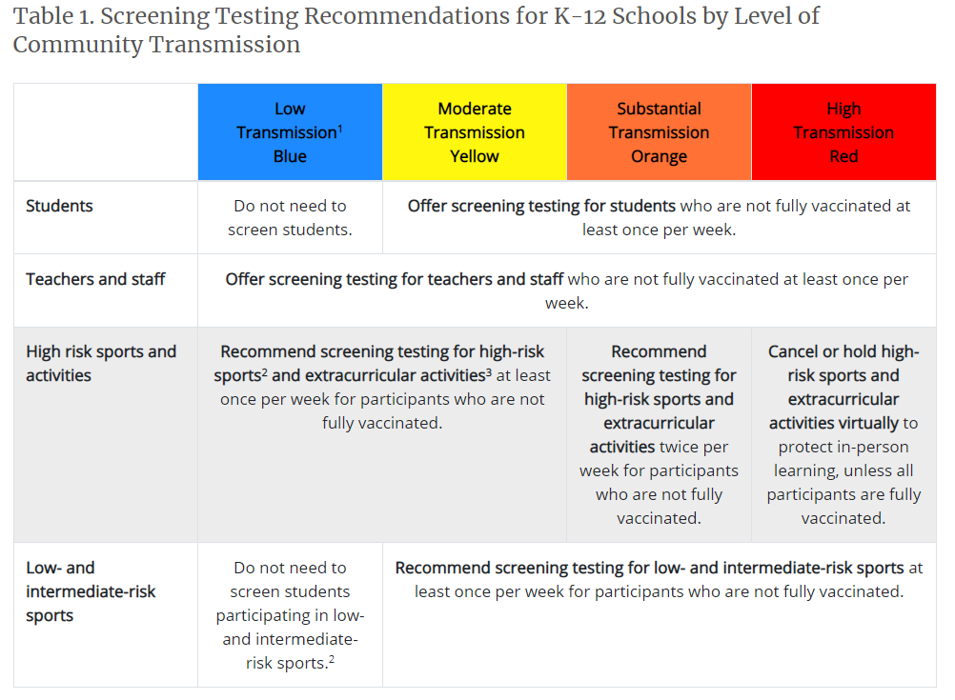
1. Levels of community transmission defined as total new cases per 100,000 persons in the past 7 days (low, 0-9; moderate 10-49; substantial, 50-99, high, ≥100) and percentage of positive tests in the past 7 days (low, <5%; moderate, 5-7.9%; substantial, 8-9.9%; high, ≥10%.)
2. The NCAA has developed a risk stratification for sports. See https://ncaaorg.s3.amazonaws.com/ssi/COVID/SSI_ResocializationDevelopingStandardsSecondEdition.pdf
Examples of low-risk sports are diving and golf; intermediate-risk sport examples are baseball and cross country; high-risk sport examples are football and wrestling.
3. High-risk extracurricular activities are those in which increased exhalation occurs, such as activities that involve singing, shouting, band, or exercise, especially when conducted indoors.

6. Ventilation. Ventilation systems clean and disperse air, decreasing the likelihood that students will inhale particles suspended in the air that are contaminated with the virus that causes COVID-19.
- Per Executive Order Two, schools should marshal available resources to improve inspection, testing, maintenance, repair, replacement and upgrades of equipment to improve the indoor air quality in school facilities, including mechanical and nonmechanical heating, ventilation, and air conditioning systems, filtering, purification, fans, control systems and window and door repair.
- In consultation with an HVAC expert, ensure the school building’s HVAC system is operating properly. The damper should be adjusted to increase the amount of exterior air that is brought in, and filters should be improved to better remove respiratory particles from the air. Exhaust fans should be run to further improve air exchange. Consider additional ways to improve ventilation, such as opening doors and windows, using window fans to direct air out of windows, or using portable room air cleaners using a HEPA filter. If doors and windows are opened, eliminate any safety hazards (e.g., do not open windows if a child could fall out).
- Reduce the risk of exposure of children and school bus drivers to the virus that causes COVID-19 by opening bus windows when possible. Consider upgrading school bus filters to a higher efficiency filter. While MERV-4 is typically used in buses, MERV-8 and even MERV-13 are available. Make sure that the filters chosen are compatible with your bus’s ventilation system.
- Refer to CDC’s information on Ventilation in Schools and Child Care Programs.

7. Implement Hand Hygiene and Respiratory Etiquette
- Teach correct handwashing to students and staff (wash with soap and water for at least twenty seconds).
- Ensure frequent access to handwashing facilities, or hand sanitizer that contains at least 60% alcohol.

8. Clean and maintain healthy facilities
- Perform regular cleaning of frequently-touched surfaces.
- SARS-CoV-2, the virus that causes COVID-19, can be reduced and killed from surfaces, objects, and hands if the right products are used correctly.
- The Environmental Protection Agency (EPA) has compiled a list of disinfectant products that can be used against the virus that causes COVID-19, including ready-to-use sprays, concentrates, and wipes.
- If there has been a sick person or someone who tested positive for COVID-19 in the school within the last 24 hours, you should clean AND disinfect the space.

9. Masks as prevention.
There are benefits and costs to mask wearing in the school environment. The benefits may include reduced transmission of the virus, but with limitations. Masks made of plain cloth, masks that are soiled or poorly fitting, and masks that are not worn properly provide reduced or no benefit; mask-wearing may cause discomfort, skin irritation, anxiety, and otherwise impact a child’s emotional state; children may have difficulty communicating, perceiving emotion, or making social connections when wearing masks. The CDC presently recommends the use of N95 or KN95 masks to reduce COVID transmission, but such masks are very tight and uncomfortable, and may be poorly tolerated by children.

During the Omicron outbreak, regions with restrictive masking policies and practices have shown similar rates of transmission as regions with less restrictive mask policies. There is presently a lack of consensus among health experts regarding the costs and benefits of mask-wearing for children in school. Parents should consult with their medical providers if they have questions about whether or not their child should mask and for how long; this is especially true if a child is at increased risk of severe illness from COVID-19, or lives with individuals at higher risk for severe illness.

In situations where a child is returning from isolation due to COVID, or was subject to a close contact exposure, the benefit of temporary masking is likely to outweigh the risks. The section on disease investigation and notifications about exposures provides more information on how the decision to wear a mask impacts the length of time a student must isolate or quarantine after illness or exposure.

References:

American Academy of Pediatrics: COVID-19 Guidance for Safe Schools. July 18, 2021.
https://services.aap.org/en/pages/2019-novel-coronavirus-covid-19-infections/clinical-guidance/covid-19-planning-considerations-return-to-in-person-education-in-schools/

Ammann, Priska, et al. "Perceptions towards mask use in school children during the SARS-CoV-2 pandemic: the Ciao Corona Study." medRxiv (2021). https://www.medrxiv.org/content/10.1101/2021.09.04.21262907v1

Smith, Jenna, Airianna Culler, and Kelsey Scanlon. "Impacts of Blood Gas Concentration, Heart Rate, Emotional State, And Memory in School‐Age Children with And without The Use of Facial Coverings in School during The COVID‐19 Pandemic." The FASEB Journal 35.

Riediker, Michael, et al. "Higher viral load and infectivity increase risk of aerosol transmission for Delta and Omicron variants of SARS-CoV-2." Swiss Medical Weekly 1 (2022). https://smw.ch/article/doi/smw.2022.w30133

CDC Guidance for COVID-19 Prevention in K-12 Schools https://www.cdc.gov/coronavirus/2019-ncov/community/schools-childcare/k-12-guidance.html

Transmission of SARS CoV-2 in Schools: CDC Science Brief: https:// www.cdc.gov/coronavirus/2019-ncov/more/science-and-research/transmission_k_12_schools.html

ED COVID-19 Handbook Volume 1: Strategies for Safely Reopening Elementary and Secondary Schools https://www2.ed.gov/documents/ coronavirus/reopening.pdf

Falk A, Benda A, Falk P, Steffen S, Wallace Z, Høeg TB. COVID-19 Cases and Transmission in 17 K–12 Schools — Wood County, Wisconsin, August 31–November 29, 2020.MMWR Morb Mortal Wkly Rep 2021;70:136–140. https://www.cdc.gov/mmwr/volumes/70/wr/ mm7004e3.htm?s_cid=mm7004e3_w

CDC Implementation of Mitigation Strategies for Communities with Local COVID-19 Transmission: https://www.cdc.gov/coronavirus/2019-ncov/community/community-mitigation.html

CDC Operating Schools during COVID-19: CDC’s Considerations https://www.cdc.gov/coronavirus/2019-ncov/community/schools-childcare/ schools.html

CDC Indicators for Dynamic School Decision-Making: https://www.cdc.gov/coronavirus/2019-ncov/community/schools-childcare/indicators.html

CDC Considerations for Monitoring and Evaluation of Mitigation Strategies Implemented in K-12 Schools: https://www.cdc.gov/coronavirus/2019-ncov/php/monitoring-evaluation-k-12.html

CDC Science Brief: Community Use of Masks to Prevent the Spread of SARS-CoV-2: https://www.cdc.gov/coronavirus/2019-ncov/science/science-briefs/masking-science-sars-cov2.html

Donohue JM, Miller E. COVID-19 and School Closures. JAMA. 2020;324(9):845-847. doi:10.1001/jama.2020.13092

Russell FM, Ryan K, Snow K, Danchin M, Mulholland K, Goldfeld S. COVID-19 in Victorian Schools: An analysis of child-care and school outbreak data and evidence-based recommendations for opening schools and keeping them open. Report from Murdoch Children’s Research Institute and the University of Melbourne. 2020; Published 2020 September 25.

CDC COVID-19 Response Team. Coronavirus Disease 2019 in Children — United States, February 12–April 2, 2020. MMWR Morb Mortal Wkly Rep. 2020;69(14):422-426. Published 2020 April 10. doi:10.15585/mmwr.mm6914e4

Dawson P, Worrell MC, Malone S, et al. Pilot Investigation of SARSCoV-2 Secondary Transmission in Kindergarten Through Grade 12 Schools Implementing Mitigation Strategies — St. Louis County and City of Springfield, Missouri, December 2020. MMWR Morb Mortal Wkly Rep. ePub: 19 March 2021. DOI: http://dx.doi.org/10.15585/mmwr. mm7012e4

Davies NG, Klepac P, Liu Y, et al. Age-dependent effects in the transmission and control of COVID-19 epidemics. Nat Med. 2020;26(8):1205-1211. doi:10.1038/s41591-020-0962-9

Dong Y, Mo X, Hu Y, et al. Epidemiology of COVID-19 Among Children in China. Pediatrics. 2020;145(6):e20200702. doi:10.1542/peds.2020- 0702

Laws RL, Chancey RJ, Rabold EM, et al. Symptoms and Transmission of SARS-CoV-2 Among Children — Utah and Wisconsin, March–May 2020. Pediatrics. 2021;147(1):e2020027268. doi:10.1542/peds.2020- 027268

Lee B, Raszka WV. COVID-19 in Children: Looking Forward, Not Back. Pediatrics. 2021;147(1):e2020029736. doi:10.1542/peds.2020-029736

Lu X, Zhang L, Du H, et al. SARS-CoV-2 Infection in Children. N Engl J Med. 2020;382(17):1663-1665. doi:10.1056/NEJMc2005073

Zimmermann P, Curtis N. Why is COVID-19 less severe in children? A review of the proposed mechanisms underlying the age-related difference in severity of SARS-CoV-2 infections. Arch Dis Child. 2020;archdischild-2020-320338. Published online ahead of print 2020 December 1. doi:10.1136/archdischild-2020-320338

Götzinger F, Santiago-García B, Noguera-Julián A, et al. COVID-19 in children and adolescents in Europe: a multinational, multicentre cohort study. Lancet Child Adolesc Health. 2020;4(9):653-661. doi:10.1016/ S2352-4642(20)30177-2

Interim Guidance: Operational Strategy and Phased Prevention for Virginia PreK-12 Schools May 17, 2021 19

Leeb RT, Price S, Sliwa S, et al. COVID-19 Trends Among SchoolAged Children — United States, March 1–September 19, 2020. MMWR Morb Mortal Wkly Rep. 2020;69(39):1410-1415. Published 2020 Oct 2. doi:10.15585/mmwr.mm6939e2

Leidman E, Duca LM, Omura JD, Proia K, Stephens JW, Sauber-Schatz EK. COVID-19 Trends Among Persons Aged 0–24 Years — United States, March 1–December 12, 2020. MMWR Morb Mortal Wkly Rep. 2021;70(3):88-94. Published 2021 January 22. doi:10.15585/ mmwr.mm7003e1

Gudbjartsson DF, Helgason A, Jonsson H, et al. Spread of SARSCoV-2 in the Icelandic Population. N Engl J Med. 2020;382(24):2302- 2315. doi:10.1056/NEJMoa2006100

Honein MA, Barrios LC, Brooks JT. Data and Policy to Guide Opening Schools Safely to Limit the Spread of SARS-CoV-2 Infection. JAMA. 2021;10.1001/jama.2021.0374. Published online ahead of print 2021 January 26. doi:10.1001/jama.2021.0374

Honein MA, Christie A, Rose DA, et al. Summary of Guidance for Public Health Strategies to Address High Levels of Community Transmission of SARS-CoV-2 and Related Deaths, December 2020. MMWR Morb Mortal Wkly Rep. 2020;69(49):1860-1867. Published 2020 Dec 11. doi:10.15585/mmwr.mm6949e2

Gold JA, Gettings JR, Kimball A, et al. Clusters of SARS-CoV-2 Infection Among Elementary School Educators and Students in One School District — Georgia, December 2020–January 2021. MMWR Morb Mortal Wkly Rep. ePub: 22 February 2021. DOI: http://dx.doi. org/10.15585/mmwr.mm7008e4

Resolve to Save Lives Fact Sheet (Draft): When and How to Close due to COVID-19 Spread: https://preventepidemics.org/wp-content/uploads/2020/04/COV020_WhenHowTightenFaucet_v3.pdf
Prevent Epidemics COVID-19 Playbook https://preventepidemics.org/ covid19/resources/playbook/#Response-4-2

Children’s Hospital of Philadelphia PolicyLab: Evidence and Guidance for In-Person Schooling during the COVID-19 Pandemic. https://policylab.chop.edu/sites/default/files/pdf/publications/

PolicyLab-Executive-Summary-Evidence-Guidance-In-Person-Schooling-COVID-19-Nov-2020.pdf (0ctober 21, 2020, updated November 5, 2020)

COVID-Local Metrics for Phased Reopening (RAND): https://covid-local.org/metrics/ The Urgency and Challenge of Opening K-12 Schools in the Fall of 2020, J.M. Sharfstein and C.C.Morphew, JAMA 2020: https://jamanetwork.com/journals/jama/fullarticle/2766822

American Academy of Pediatrics COVID-19 Planning Considerations: Guidance for School Reentry https://services.aap.org/en/pages/2019-novel-coronavirus-covid-19-infections/clinical-guidance/covid-19-planningconsiderations-return-to-in-person-education-in-schools/

National Academy of Sciences, Engineering, and Medicine 2020. Reopening K-12 Schools During the COVID-19 Pandemic: Prioritizing Health, Equity, and Communities. Washington, D.C.: The National Academies Press. https//doi.org/10.17226/25858

Executive Summary: Evidence and Guidance for In-Person Schooling during the COVID-19 Pandemic. https://policylab.chop.edu/sites/default/files/pdf/publications/PolicyLab-Executive-Summary-Evidence-Guidance-In-Person-Schooling-COVID-19-Nov-2020.pdf

